Browser
|
| HTTP Request
v
server.js / app.js
|
v
Express Middleware(auth,autho,cors,csrf)
|
v
Route Definition
|
v
JWT Authentication
|
v
Controller / Handler
|
v
Business Logic
|
v
Nunjucks Template Engine
|
v
HTML Response
|
v
Browser

Step 1: Identify the entry point
Open your practice project's package.json.

{
"scripts": {
"start": "node server.js"
}
}

2.Start Node.js in debugging mode
If your entry point is server.js, open the terminal in the project directory and run:node --inspect-brk server.js

if it is app.js use the below command
node --inspect-brk app.js

Node.js will start in debugging mode and pause near the beginning of execution.

Step 3: Open Chrome DevTools
1. Open Google Chrome.
2. Navigate to chrome://inspect.
3. Find your Node.js process under Remote Target.
4. Click inspect.
Chrome DevTools should open with the JavaScript debugger.

Step 4: Follow the code
In Chrome DevTools, open the Sources panel.

You can then:
- Set breakpoints by clicking beside line numbers.
- Step over or into function calls.
- Inspect variables.
- Follow middleware execution.
- Examine the call stack.
For your Express.js application, this will let you investigate the same JavaScript execution concepts that you will use when debugging TypeScript in IntelliJ Ultimate.

Security note: Keep the Node.js inspector bound to localhost. Avoid exposing the debugging port to your network.

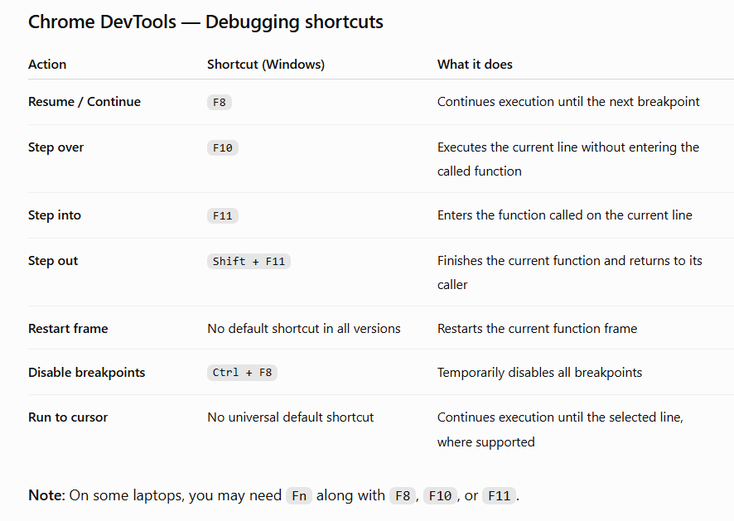

When execution pauses:
- Press F11 (Step into) to enter getUser().
- Press F10 (Step over) to execute one line at a time inside the function.
- Press Shift + F11 (Step out) to finish getUser() and return to showDashboard().
- Press F10 to execute the next line.
- Press F8 to continue to the next breakpoint.
Remember these four shortcuts
- F10 → Next line
- F11 → Enter function
- Shift + F11 → Exit function
- F8 → Continue to next breakpoint
These are the standard Chrome DevTools shortcuts on Windows. You can also find them in Chrome DevTools under Settings → Shortcuts.

I am using IntelliJ IDEA Community Edition. Guide me through Node.js debugging setup.
Since you are using IntelliJ IDEA Community Edition, we need a slightly different approach.
You can still run and debug your Express.js + TypeScript application while keeping IntelliJ Community as your code editor.
My recommendation: Use IntelliJ Community + Node.js Inspector + Chrome DevTools.
This lets you:
- Set breakpoints in your TypeScript code.
- Pause application execution.
- Inspect variables.
- Step into and over functions.
- Examine the call stack.
- Debug Express middleware and controllers.

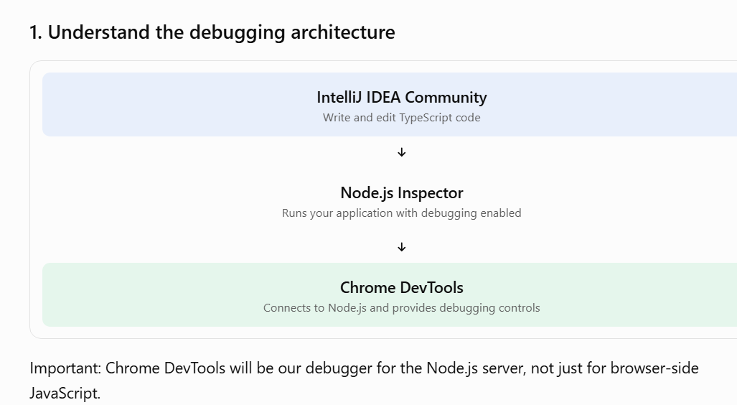
2.. Check your project configuration
Open the IntelliJ Terminal using:Alt+F12
Execute
node -v
npm -v
Then check whether tsx is installed:
npm list tsx

I will assume your application starts from src/server.ts. If your entry point is different, substitute the actual filename.

3. Add a debugging script to package.json
Open package.json.
Inside scripts, add:

{
"scripts": {
"dev": "tsx watch src/server.ts",
"debug": "node --inspect-brk=127.0.0.1:9229 --import tsx src/server.ts"
}
}
Keep your existing scripts; just add the debug entry.
What does this command mean?

node --inspect-brk=127.0.0.1:9229 --import tsx src/server.ts
Part | Explanation
node | Starts Node.js
--inspect-brk | Enables debugging and pauses at startup
127.0.0.1:9229 | Debugger listening address and port
--import tsx | Loads the TSX TypeScript runtime
src/server.ts | Starts your application
Port 9229 is the debugger port. Your Express application might continue to use port 3000. They serve different purposes.

4. Start the application in debug mode
From IntelliJ Terminal:
npm run debug
You should see something similar to:
Debugger listening on ws://127.0.0.1:9229/...
For help, see: https://nodejs.org/en/docs/inspector

Debugger attached.

Your application will initially pause because we used --inspect-brk.
Do not terminate this process.

5. Connect Chrome DevTools to Node.js
Open a new Chrome tab:

chrome://inspect
- Set breakpoints in your TypeScript files
To set a breakpoint:
- Open the file in Chrome DevTools Sources.
- Click the line number.
- A blue breakpoint marker should appear.

If you are not able to see your ts file and only system and internal files are visible then just

If the TypeScript files aren't immediately visible, press Ctrl + P in the Sources panel and search for notFoundHandler.ts. TSX supplies source maps to help the debugger map executed JavaScript back to your TypeScript source.
my ts file is not coming under resource .some other files are coming .
This is most likely a TypeScript source-map or debugger file-discovery issue in Chrome DevTools.
Since you are using IntelliJ Community + Node.js Inspector, let's troubleshoot it.
1. First check whether TypeScript source maps are enabled
Open your tsconfig.json.
Check whether you have:

"compilerOptions": {
"target": "ES2020",
"module": "CommonJS",
"rootDir": "src",
"outDir": "dist",
"strict": true,
"esModuleInterop": true,
"forceConsistentCasingInFileNames": true,
"skipLibCheck": true,
"sourceMap": true,
"inlineSources": true
}
The important settings are:
- sourceMap: true – generates source map information.
- inlineSources: true – embeds the original TypeScript source in the source map.
Keep your existing module and moduleResolution values if they are working. Don't change them just for debugging.
Now start the application in debug mode and set the breakpoint in your ts file hit the request and check and debug

Shortcut | Meaning
F8 – Resume | Jump to the next breakpoint. Continue running the application.
F10 – Step Over | Execute the current line and move to the next line without entering the called function.
F11 – Step Into | Go inside the function being called and debug its code.
Shift + F11 – Step Out | Finish executing the current function and come back to the calling function.

